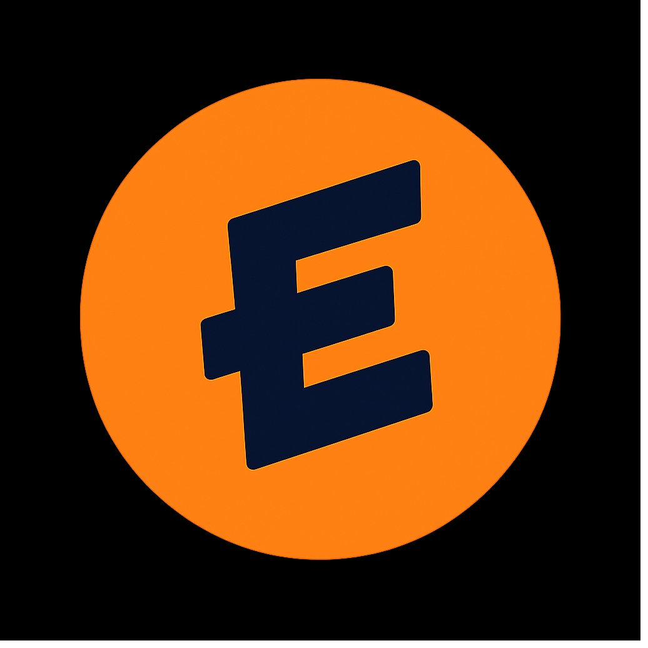
THE HUNGER NETWORK
A White Paper
How $EAT identifies and funds the top hunger-relief organizations in the world
■ ■ ■
Published by WYDE Association
A Wyoming Decentralized Unincorporated Nonprofit Association
501(c)(4) Social Welfare Organization
April 2026 · Version 1.0 · eat.ong/network

Executive Summary
The Hunger Network is the public infrastructure layer of $EAT. It does two jobs at once. It connects people in need with verified hunger-relief organizations near them, and it routes the cause-pool fees generated by $EAT trading to the organizations doing the most credible work.
Every cause fee generated by $EAT splits into two pools, each receiving 50%. The first funds the Exclusive National Partner, Feed the Children, through an 18-month grant agreement with WYDE Association. The second is the Community-Voted Pool, the focus of this paper. This document explains the phased approach the network uses to identify the top organizations that receive that second 50%, and the mechanics by which network members direct funding among them every month.
Three things make this model different from traditional grant-making. The candidate set is curated and verified before votes are cast, so every organization on the ballot is already approved for grant disbursement. The top ten organizations each round receive funding, not just the single winner, with allocations weighted by community votes. The entire flow is published on-chain, so any donor, regulator, or partner can verify what was raised, who voted, and where the money went.

The Problem
Forty-seven million Americans face food insecurity. One in seven people. One in five children. The hunger-relief sector receives roughly $4.27 billion in annual charitable giving. Feeding America operates more than 200 food banks and 60,000 food pantries. Last year, those organizations distributed 9.7 billion meals.
The infrastructure to feed people exists. The funding to operate it does not, at least not at the scale the moment requires. In early 2026, the One Big Beautiful Bill Act cut $187 billion from SNAP over ten years. 2.4 million people are losing eligibility. States face cost shifts from 50% to 75% of administrative expenses. Food banks report record demand while grocery prices remain more than 29% above 2020 levels.
Traditional charitable giving is campaign-based. Donors have to remember, decide an amount, trust the destination, and repeat the process. The result is uneven funding flowing to the largest, most-marketed organizations and leaving regional operators undercapitalized. The Hunger Network removes that friction at the structural level. A community of members participates in a network. The network generates fees through trading and member spending. Those fees fund the WYDE Association treasury. The treasury makes monthly grants to verified hunger-relief organizations. Members hold governance rights and vote on which organizations receive each round's allocation. The transparency is structural, not promised.

The Hunger Network
The Hunger Network is a public directory and allocation layer hosted at eat.ong. It pulls registry data from the IRS Business Master File, then layers verification, claim, and content tools on top. Any 501(c)(3) hunger-relief organization (or international equivalent) operating one year or more with a mission aligned to ending hunger can be listed and verified. Verified organizations become eligible for monthly grant funding.
The network does three jobs simultaneously. It helps people find food through an open, free, account-less directory searchable by ZIP code or city. It gives organizations a public operating layer where verified groups publish needs, stories, and updates through the same shell people use to find help. And it makes the allocation model legible, with cause-pool fees, partner pool, community-voted pool, and per-round results all published on-chain and surfaced through the directory.
The network is the on-ramp. The funding mechanism is participation in the WYDE network — members trading $EAT, holding $EAT, and using the $EAT Card. Members hold governance rights and vote each month on which organizations receive grants. The grant-making entity is WYDE Association, a Wyoming Decentralized Unincorporated Nonprofit Association with 501(c)(4) status. Fees generated by network activity flow to WYDE Association, which then makes charitable grants to recipient organizations.

The compliance flow in one sentence. Member network activity generates fees that fund the WYDE Association treasury, which makes charitable grants to verified hunger-relief organizations on a published cadence.

The 50/50 Cause Pool
Every cause-pool fee generated by $EAT activity is allocated to verified hunger-relief organizations through two pools.

50%  EXCLUSIVE NATIONAL PARTNER  Feed the Children. 18-month grant agreement effective April 1, 2026. National-scope hunger relief. | 50%  COMMUNITY-VOTED POOL  Top ten organizations per round, weighted by member votes. Curated candidate set, quadratic weighting.

The 50% Exclusive National Partner pool is straightforward. WYDE Association makes grants to Feed the Children on a published schedule. The agreement is in force for 18 months from April 1, 2026, and includes a $50,000 minimum grant guarantee. No other national hunger-relief organization receives grants from WYDE Association in connection with $EAT during that term.
The 50% Community-Voted pool is the subject of the rest of this paper. It is the discovery and distribution layer of the network, built on the premise that hunger relief is local. Regional food banks, community pantries, school-meal programs, and international operators serve populations a single national grantee cannot reach efficiently. The community pool is how the network identifies and funds those operators.

End-to-End Governance Flow
Trade or card swipe to grant disbursement, with the feedback loop that compounds the system. Orange arrows are the flywheel: every meal funded becomes proof that drives the next round of trades, cardholders, and members.

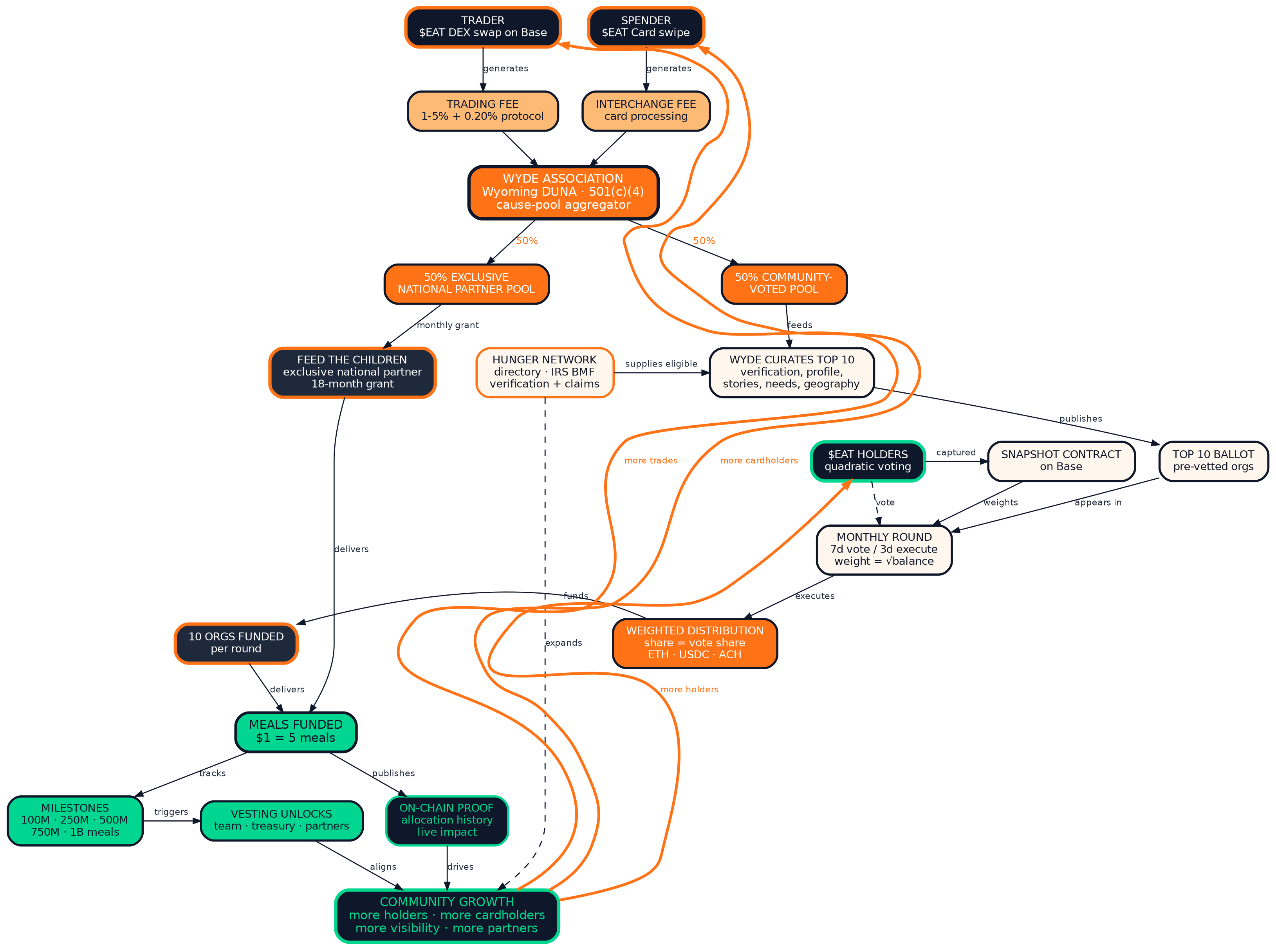

The Phased Approach
The network does not try to do everything on day one. It rolls out in phases. Each phase is a working layer of the system. Earlier phases are live now. Later phases activate as the network reaches the volume and integrity thresholds that make them work.

01 | Public Directory  Live. The open registry layer.

- IRS Business Master File data is surfaced as the registry baseline. Every U.S. 501(c)(3) hunger-relief organization is discoverable in the directory.
- Search is free, public, and works without an account. ZIP code, city, and category filters route people in need directly to verified organizations.
- Organizations claim their listing in roughly two minutes and pass IRS-status verification. Free forever. Optional Boost and Partner tiers add visibility but do not affect allocation outcomes.

02 | Verification and Eligibility  Live. The trust layer.

- Verified organizations publish needs, stories, and operational updates through the same shell people use to find help.
- Verification is the gating condition for nomination. An organization that has not claimed and verified its listing cannot enter a voting round.
- Both U.S. and international organizations are eligible to be nominated. The U.S. directory is the priority through 2026, with international expansion accelerating into 2027.

Subject to refinement. The voting design described in Phases 03 and 04 and in the Voting Mechanics section below reflects the current architecture. Final mechanics are subject to refinement as the system goes live. Any material changes will be published before the first community-voted round opens.

03 | Curated Top Ten  Activating. The identification layer.

- Each round, WYDE Association publishes a curated set of ten verified organizations. This is the candidate ballot for the round.
- Eligibility is straightforward: a 501(c)(3) (or international equivalent) operating one year or more, with a valid program offering and a mission aligned to ending hunger.
- Curation uses signals from the network itself. Verification status, profile completeness, frequency of stories and needs filed, geographic balance, current operational scale, demonstrated need, and standing in the directory.
- Every organization on the ballot is pre-approved for grant disbursement by WYDE Association before voting opens. There is no scenario in which members vote for an organization that cannot receive the grant.
- This step is structurally important. It removes the burden of due diligence from the community while preserving democratic allocation among legitimate operators. It is the difference between an open vote and a curated index.

04 | Community Vote and Allocation  Activating. The distribution layer.

- Members vote on the curated ten. Voting power is proportional to token holdings at snapshot, captured by a custom on-chain contract.
- Quadratic weighting is applied. A member's effective vote weight is the square root of their token count. Broad community support outweighs concentrated holdings.
- Each round runs ten days. Seven for voting, three for execution. Cadence is monthly.
- All ten organizations receive an allocation, weighted by share of votes received. The design is similar to a curated token-index basket, where composition is fixed and weights flex with signal.
- Grants disburse in the recipient's preferred rail: ETH, USDC, or ACH transfer.

05 | Expansion and Multi-Cause Template  On the horizon. The scaling layer.

- International expansion extends the curated ballot beyond the U.S. The mechanism is the same. The candidate pool widens.
- The Hunger Network is the proof of concept for the broader Impact Exchange. Once hunger is functioning at scale, the same directory plus curated-vote architecture can run on water, education, healthcare, climate, and housing.
- Each new cause is a new vertical. Each vertical can have its own cause coin, its own cause pool, and its own community. The network shell is cause-agnostic by design.

Voting Mechanics in Detail
Six parameters define how a round runs. Each is published before the round opens, and each is auditable on-chain after the round closes.

Eligibility. Verified organizations operating one year or more, with a valid program offering and mission aligned to ending hunger. WYDE Association curates the slate of ten from the eligible pool. Boost and Partner paid tiers do not influence inclusion.
Snapshot. $EAT balances are captured by a custom snapshot contract at the moment voting opens. Balance changes during the voting window do not affect the snapshot.
Vote weight. Quadratic. A member with 10,000 $EAT casts 100 effective votes. A member with 1,000,000 $EAT casts 1,000 effective votes. The square-root function flattens the weight of the largest members relative to broad participation.
Allocation formula. All ten organizations on the slate receive a grant. Each organization's share of the round's community pool equals its share of total quadratic votes. An organization that receives 25% of the round's vote weight receives 25% of the round's pool.
Cost-per-meal standard. Grant amounts are converted to estimated meals funded using the WYDE aggregate target of $1 equals 5 meals. This is more conservative than Feeding America's $1 equals 10 meals figure and is used consistently across all $EAT impact reporting.
Cadence and execution. Rounds run monthly. Each round opens on the first Monday and closes seven days later. The execution window is three days. Grants are disbursed by the second Friday of the month in ETH, USDC, or ACH at the recipient's election.

For Hunger-Relief Organizations
Eligibility is straightforward. A 501(c)(3) (or international equivalent) operating one year or more, with a valid program offering and a mission aligned to ending hunger. Food banks, regional pantries, school-meal programs, soup kitchens, mobile distribution, hunger associations, and similar operators all qualify regardless of size, region, or budget.
Three actions move an organization from the open registry to fundable status. Every step is free.

1  Claim  Find your IRS-listed organization in the directory. Claim ownership in two minutes. | 2  Verify  Confirm your 501(c)(3) status and one-year operating history. Add logo, mission, contact, current needs. | 3  Become Eligible  Once verified, you are eligible to be nominated for the curated ballot in any voting round.

Claiming and verification establish eligibility but do not guarantee an allocation. Selection onto the curated ballot is influenced by network signals (verification, profile completeness, stories, needs, geographic balance), not paid-tier status. Boost and Partner add visibility, never allocation weight.

Free vs. Premium Directory Listing
The Hunger Network offers a free path and an optional Premium Directory Listing tier. Eligibility for monthly funding rounds is identical between the two — paying does not influence allocation, vote outcomes, or grant size. Premium exists for organizations that want amplified visibility in the directory.

BENEFIT | FREE  Claim & Verify | PREMIUM  Directory Listing
ELIGIBILITY & FUNDING
Eligibility for monthly funding rounds | ✓ Included | ✓ Identical
Equal weight in selection | ✓ Included | ✓ Identical
Receive grants if selected | ✓ Included | ✓ Identical
Pay-to-play allocation advantage | — Never | — Never
DIRECTORY PRESENCE
Listed in public directory | ✓ Standard listing | ✓ Featured placement
Search result prominence | ✓ Standard ordering | ✓ Top of local searches
Verified badge | ✓ Standard verified mark | ✓ Premium member badge
Profile depth | ✓ Mission, contact, basic info | ✓ Extended bio, expanded story
Custom donation link | — Not included | ✓ Add your donation page
STORYTELLING & CONTENT
Publish current needs | ✓ Standard need listings | ✓ Featured needs across network
Publish stories and updates | ✓ Standard timeline | ✓ Highlighted in network feed
Image and video uploads | — Profile image only | ✓ Unlimited
TOOLS & SUPPORT
Profile analytics | — Not included | ✓ Views, traffic, engagement
Verification & support response | ✓ Standard | ✓ Priority response

Both tiers are designed to do the same job: connect verified hunger-relief organizations to a community-funded grant treasury. The free tier does that job completely. Premium does it with amplification across the WYDE network surface area.

Trust, Compliance, and Transparency
Five layers of structural trust support the model. Every dollar can be traced and every grant can be audited.

Members are not donors. Members participate in the WYDE network and hold governance rights — they vote each month on which organizations receive grants from the treasury. They also receive member benefits (debit card access, partner discounts, rewards from trading competitions, and more). Grants are paid from the WYDE Association treasury, not from any individual member's personal contribution. The distinction is structural and legally important.

WYDE Association is the grant-maker. WYDE is a Wyoming DUNA with IRS 501(c)(4) determination. Members participate in the network. The network generates fees. Fees fund the Association treasury. The Association makes the grant. This buffer is load-bearing for both regulatory clarity and accurate public framing.
Pre-vetted candidate ballots. Every organization on a voting round's slate has already passed WYDE Association diligence — confirming 501(c)(3) status (or international equivalent), one-year operating history, valid program offering, and mission aligned to ending hunger. The vote determines weighting, not approval.
On-chain transparency. Cause-pool inflows, snapshot balances, vote tallies, and grant disbursements are recorded on Base. Allocation history is published at eat.ong/allocation-history. Live impact metrics are at eat.ong/live-impact.
Decentralized governance. The Wyoming DUNA statute creates a legal entity with no shareholders, no traditional board, and no centralized management providing essential managerial efforts. Governance is community-driven through member voting. This is structural, not cosmetic.
Conservative impact accounting. WYDE uses $1 equals 5 meals as the aggregate target across reporting. Some sector references use 10 meals per dollar. The conservative figure keeps impact claims defensible.
The directory is live. Verification is open. The curated-ballot model and the custom snapshot contract are activating now. The first community-voted rounds will run on a public schedule once the candidate-set curation process is published. Round results will be reported in the quarterly impact report alongside the partner-pool grant data.
To learn more, visit eat.ong/network. To claim a listing, visit eat.ong/claim/start. To follow allocation results in real time, visit eat.ong/live-impact.

